6-2 In Section 6.4.2, we classified design goals into five categories: performance,

dependability, cost, maintenance, and end user. Assign one or more categories to each

of the following goals:

* Users must be given feedback within one second after they issue any command.
  + Design
* The TicketDistributor must be able to issue train tickets, even in the event of a network failure.
  + Dependability
* The housing of the TicketDistributor must allow for new buttons to be installed in case the number of fares increases.
  + Maintenance
* The AutomatedTellerMachine must withstand brute force attacks (i.e., users attempting to discover a identification number by systematic trial).
  + Dependability

6-5 Consider the model/view/control example depicted in Figures 6-17 and 6-16

1. Redraw the communication diagram of Figure 6-17 as a sequence diagram.
   1. A picture containing darkness, screenshot

      Description automatically generated
2. Discuss how the MVC architecture helps or hurts the following design goals:
   1. Extensibility (e.g., the addition of new types of views)
      1. Helps design goal by being modular, encourages loose coupling, and allows for individual components to be tested.
   2. Response time (e.g., the time between a user input and the time all views have been updated)
      1. Since the user view can only be updated after the model has been update.. this would hurt the design goal
   3. Modifiability (e.g., the addition of new attributes in the model)
      1. With individual attribute windows able to be updated, and not all at once, this helps the design goal.
   4. Access control (i.e., the ability to ensure that only legitimate users can access specific parts of the model).
      1. MVC helps the goal because the model can be accessed with a clear interface.

7-1 Consider a system that includes a Web server and two database servers. Both database

servers are identical: the first acts as a main server, and the second acts as a redundant

back-up in case the first one fails. Users use Web browsers to access data through the

Web server. They also have the option of using a proprietary client that accesses the

databases directly. Draw a UML deployment diagram representing the hardware/software mapping of this system.

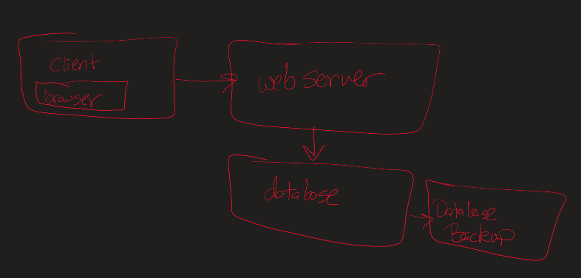

7-3 You are designing the access control policies for a Web-based retail store. Customers access the store via the Web, browse product information, input their address and payment information, and purchase products. Suppliers can add new products, update product information, and receive orders.The store owner sets the retail prices, makes tailored offers to customers based on their purchasing profiles, and provides marketing services. You have to deal with three actors: StoreAdministrator, Supplier, and Customer. Design an access control policy for all three actors. Customers can be created via the Web, whereas Suppliers are created by the StoreAdministrator

|  |  |  |  |  |
| --- | --- | --- | --- | --- |
|  | Product | Customer Info | Supplier Info | Order |
| Customer | See product info  See product pricing | Update existing account |  | Create an order |
| Supplier | Create order  Product info  Update product info |  | Update supplier info | Get order info |
| Store admin | Update pricing | Verify customer  Check customer profile  Get an offer from the customer | Add supplier | Check orders |
| New Customer | See product info  See product pricing | Create a user account |  |  |

